FABRIC Deploy Demo Steps And Q&A

Prerequisites:
- Golang
One solution to use go to build fabric source code to get deploy tools(cryptogen, configtxlator, configtxgen, peer, orderer)
Install and config go env path steps:
- Download golang version you need refer to https://studygolang.com/dl
- Extract tar to path as ”/usr/local” as below:
cd 下载
sudo tar -C /usr/local -xzf go1.10.3.linux-amd64.tar.gz
- Make a go projects folder “Goproject” to put go projects
mkdir $HOME/go
- Config env path(edit “~/.bashrc” for current user or “/etc/profile” for all users) to add:
export GOROOT=/usr/local/go
export GOPATH=$HOME/Goproject
export PATH=$PATH:$GOROOT/bin:$GOPATH/bin

Then, save the file
source ~/.bashrc
source /etc/profile
- Check if go install success
go version
go version go1.10.3 linux/amd64

- Git
Install and check git version
sudo apt install git
git version

- Clone fabric and fabric-samples source code to local
cd $GOPATH/src
mkdir -p github.com/hyperledger
cd github.com/hyperledger
git clone https://github.com/hyperledger/fabric.git

- Docker, Docker-Compose
- Docker-CE installation refer to
https://blog.csdn.net/Computer_hello/article/details/79708267
- Docker-Compose installation refer to https://segmentfault.com/a/1190000015985192#articleHeader4

- Pull fabric related docker images
① Solution 1
- website: DockerHub, search Hyperledger
- docker pull hyperledger/fabric-peer:x86_64-1.0.0
- Fabric main need images:
hyperledger/fabric-tools
hyperledger/fabric-orderer
hyperledger/fabric-peer
hyperledger/fabric-couchdb
hyperledger/fabric-kafka
hyperledger/fabric-ca
hyperledger/fabric-zookeeper
hyperledger/fabric-baseos
② Solution 2
Directly run the shell script under fabric/bin/get-docker-images.sh

Q&A
- It’s better to math the version between docker images and fabric source code
- When you run command “docker ps” to check all the docker we have for now, you may got this message “Got permission denied while trying to connect to the Docker daemon socket at unix:///var/run/docker.sock: Get http://%2Fvar%2Frun%2Fdocker.sock/v1.39/containers/json: dial unix /var/run/docker.sock: connect: permission denied”. It’s due to we don’t set manage Docker as a non-root user for the current user.
sudo groupadd docker #Add docker user group
sudo gpasswd -a $USER docker #Add current user to the docker user group
newgrp docker #update user group
docker ps #test the update

Note:
Step1, 2, 3 not all need in every peer node , but step 4, 5 do, so we can package all docker images, distribute to different nodes, reduce deploy period.

Deploy Demo:
Single PC(ubuntu)
Include :
1 orderer, 2 organization(1 peer for each organization), chaincode(fabric source demo under path examples/chaincode/go/chaincode_example02)

192.168.3.2

Orderer

Chain code
Org1

Org2

a
Peer0
Peer0

All related config yaml files can found on git, deploy tools(cryptogen, configtxgen... etc) can also get from here expected for build from source code as we talked above.
Final deploy path as below:
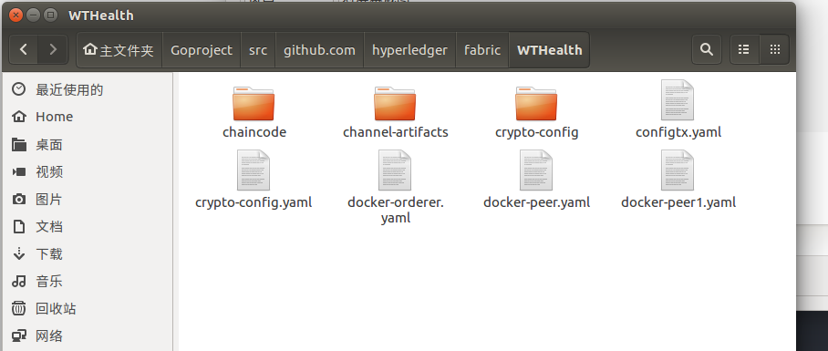

Step 1: create crypto-config.yaml file to create authority files(under folder crypto-config).
./bin/cryptogen generate --config=./crypto-config.yaml
# 返回信息
org1.example.com
org2.example.com
Step 2: create configtx.yaml to generate genesis block
mkdir channel-artifacts
./bin/configtxgen -profile TwoOrgsOrdererGenesis -outputBlock ./channel-artifacts/genesis.block
./bin/configtxgen -profile TwoOrgsChannel -outputCreateChannelTx ./channel-artifacts/mychannel.tx -channelID mychannel

Step 3: create docker-orderer.yaml to deploy orderer node
docker-compose -f docker-orderer.yaml up -d

PS(common cmd may be used):
docker ps // check if orderer docker create successfully
docker rm -f $(docker ps -aq) // use this to delete all the container before deploy or clean up current deployed containers

Step 4: create docker-peer.yaml to deploy the first peer node in org1
docker-compose -f docker-peer.yaml up -d

After finished 4 steps above we got a simple fabric net with 1 orderer, 1 peer node, will install the first chaincode on peer0.org1.example.com.

Step 5: create channel, peer join, install and execute chaincode demo
docker exec -it cli bash
peer channel create -o orderer.example.com:7050 -c mychannel -f ./channel-artifacts/mychannel.tx
peer channel join -b mychannel.block
peer chaincode install -n mychannel -p github.com/hyperledger/fabric/wthealth/chaincode/go/ -v 1.0

// Initial user A, B
peer chaincode instantiate -o orderer.example.com:7050 -C mychannel -n mychannel -c '{"Args":["init","A","10","B","10"]}' -P "OR ('Org1MSP.member')" -v 1.0

//Query user A
peer chaincode query -C mychannel -n mychannel -c '{"Args":["query","A"]}'
//Transition, A to B, 5
peer chaincode invoke -C mychannel -n mychannel -c '{"Args":["invoke", "A", "B", "5"]}'
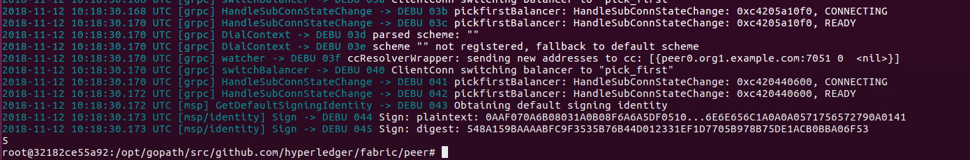

Now, after step 1 to 5, we got a orderer node and a peer node in org1, let’s try to add a new peer node in org2.

Step 5: create docker-peer1.yaml in org2, start docker and install chaincode on it.
docker-compose -f docker-peer1.yaml up -d
docker ps //check peer0.org2.example.com container start

Note:
Because cli container binding to peer0.org1, if we want to operate peer0.org2 via cli, we need update cli’s env from peer0.org1 to peer0.org2, as command below:
CORE_PEER_ID=peer0.org2.example.com
CORE_PEER_ADDRESS=peer0.org2.example.com:7051
CORE_PEER_CHAINCODELISTENADDRESS=peer0.org2.example.com:7052
CORE_PEER_GOSSIP_EXTERNALENDPOINT=peer0.org2.example.com:7051
CORE_PEER_LOCALMSPID=Org2MSP
CORE_PEER_TLS_ROOTCERT_FILE=/opt/gopath/src/github.com/hyperledger/fabric/peer/crypto/peerOrganizations/org2.example.com/pe ers/peer0.org2.example.com/tls/ca.crt
CORE_PEER_MSPCONFIGPATH=/opt/gopath/src/github.com/hyperledger/fabric/peer/crypto/peerOrganizations/org2.example.com/users /Admin@org2.example.com/msp

Then, do the same chaincode install steps
peer channel join -b mychannel.block
peer chaincode install -n mychannel -p github.com/hyperledger/fabric/wthealth/chaincode/go/ -v 1.0
//Query A
peer chaincode query -C mychannel -n mychannel -c '{"Args":["query","A"]}'

Q&A
- Confused with the config parameters in the .yaml files?
- https://zhuanlan.zhihu.com/p/36071226
- https://bingohuang.gitbooks.io/docker_practice/content/compose/yaml_file.html#containername
- Pay attention to the fields “volumes:”, “ports”,
volumes:
// local path and running deploy path mapping, need pay attention
- ./chaincode/go/:/opt/gopath/src/github.com/hyperledger/fabric/wthealth/chaincode/go
- ./crypto-config:/opt/gopath/src/github.com/hyperledger/fabric/peer/crypto/
- ./channel-artifacts:/opt/gopath/src/github.com/hyperledger/fabric/peer/channel-artifacts

ports:
// service ports mapping physics ports
- 7051:7051
- 7052:7052
- 7053:7053

Now we finished deploy a simple fabric.

Extend:
Extend deploy more other new orgs on other PCs.
- https://blog.csdn.net/zhayujie5200/article/details/82529167
- Git : https://github.com/zhayujie/fabric-tools
https://github.com/aberic/fabric-net-server

Chaincode demo
- https://www.cnblogs.com/preminem/p/7754811.html
- Marbles

